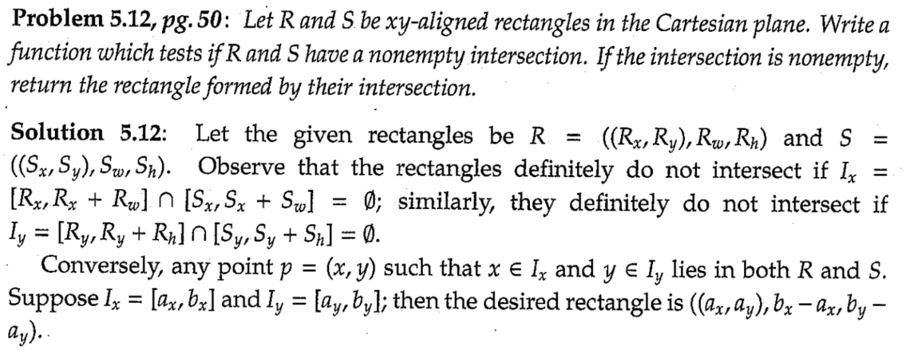

**#include** <iostream>

**#include** <algorithm>

**class** Rectangle {

**public**:

**Rectangle**(**int** x, **int** y, **int** w, **int** h) :

x(x), y(y), width(w), height(h) {

}

;

**int** x, y, width, height;

};

**bool** **is_intersect**(**const** Rectangle &R, **const** Rectangle &S) {

**return** R.x <= S.x + S.width && R.x + R.width >= S.x &&

R.y <= S.y + S.height&& R.y + R.height >= S.y;

}

Rectangle **intersect_rectangle**(**const** Rectangle &R, **const** Rectangle &S) {

**using** **namespace** std;

**if** (is_intersect(R, S)) {

**return** {max(R.x,S.x),

max(R.y,S.y),

min(R.x+R.width,S.x+S.width)-max(R.x,S.x),

min(R.y+R.height,S.y+S.height)-max(R.y,S.y)};

} **else** {

**return** {0,0,-1,-1};

}

}

**int** **main**() {

**using** **namespace** std;

Rectangle a(0, 0, 10, 10);

Rectangle b(5, 5, 10, 10);

Rectangle c = intersect_rectangle(a, b);

cout << c.x << "," << c.y << "," << c.width << "," << c.height << **endl**;

}